Major Grant - Intent to Apply

cfmarshallco@gmail.com

“Intent to Apply” must be submitted electronically
by 12:00 p.m. on December 15th
Grant is a maximum of $20,000

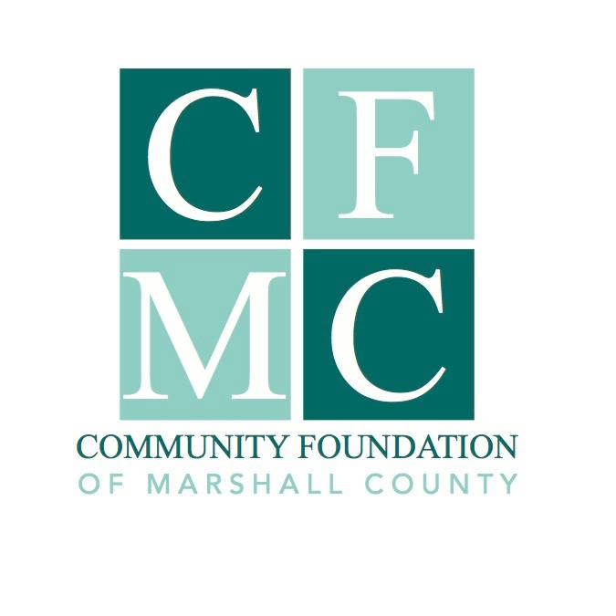

An Intent to Apply Form (due by noon on 12/15/17) is required for anyone interested in applying for a Major Grant of up to $20,000. The CFMC board will review the forms and invite up to 3 applicants to submit a full application requesting funding. If selected, these applications will be due by 12:00 p.m. on January 15, 2018.

Do not submit support materials with the “Intent to Apply.” The Intent to Apply is not binding and does not enter into the review of a subsequent application.

Applying organization:
Contact person:
Position in organization:
Applying agency address:
City, State, Zip:
Phone number:
Email:
Type of applying organization: 501(c)(3) non-profit organization
local government: type
Federal tax identification number of organization:

Fiscal sponsor information is only needed if different than the applying organization.
Name of fiscal sponsor (if different than applying organization):
Federal tax identification number of fiscal sponsor:
Fiscal agency address:
City, State, Zip:
Phone number:
Email:

Project name:

Approximate total cost of proposed project:

Approximate amount to be requested:

Sources for additional funding required for the project:

Brief description of the project and who it will benefit (No more than 1 page):

________________________________________________ ___________________________
Authorized Project Representative Date

Printed name:

Please submit this document electronically to cfmarshallco@gmail.com before by 12:00 p.m. December 15, 2017.

