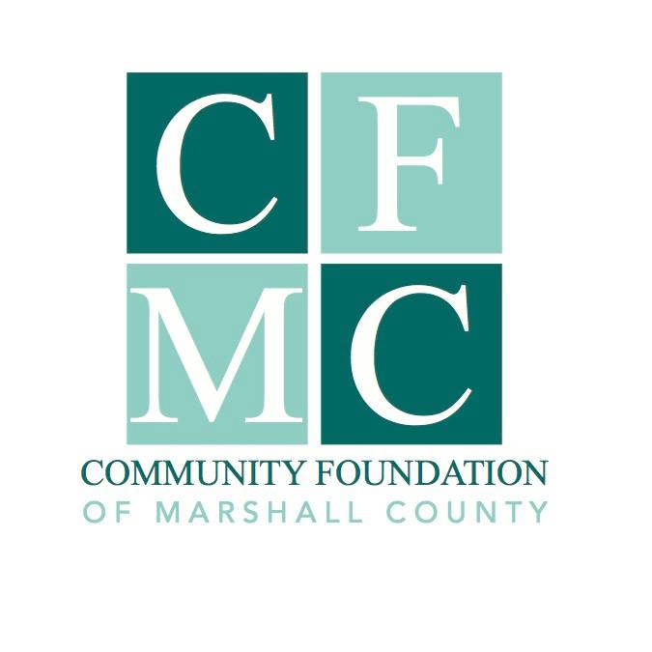
2019 Community Foundation of Marshall County Major Impact Grant Guidelines

Grant Guidelines

The 2019 Community Foundation of Marshall County (CFMC) Major Impact Grant will provide up to $20,000 in funding to an organization’s project that will have a lasting impact on how the citizens of Marshall County live, work, learn or play. Funding decisions are made through a competitive application process which is described below.

This grant opportunity is open, by invitation only, through the Letter of Intent process. All invited grant application submissions must include the completed application, along with a detailed budget.

Grant Cycle Timeline

August 19th: Grant guidelines released
September 16th: Letters of intent due
October 1st: Invitation to apply
November 1st: Application due
November 22nd: Grant award announcement

Eligibility

Funding is available to non-profit, I.R.S. 501(c)(3) tax-exempt organizations, 170(b) units of government organizations or charitable organizations without the above designations through a qualified fiscal sponsor. It is preferred that only one proposal is submitted per organization.

Letter of Intent

Letters of intent should be no more than two pages in length, using 12 point font, single spaced. They should include a narrative of the project and demonstrate the following:

*Brief proposed project description
*How the proposed project will have a lasting impact on how the citizens of Marshall County live, work, learn and play.
*Total project cost, amount requested from this grant and other secured funding
*If warranted, how the proposed project fulfills one or more of the priorities listed below.

Projects given priority

>Projects based in community plans (i.e. city plans, community visioning plans).
>Address community challenges, underserved populations and/or service gaps.
>Articulate desired results, effective methods and viable plans for ongoing efforts
>Include a realistic project budget and financial information that demonstrate financial health
>Incorporate fresh, innovative approaches that are based on research, experience and best practices in the field
>Use collaborative strategies that support efficiencies, increase effectiveness and build leadership for achieving broader impact without duplication.
>Possess broad-based support
>Build on community strengths
>Support and welcome an increasingly diverse community
>Leverage the proposed CFMC grant with other financial and human resources
>Exhibit a well-planned approach, committed leadership and the involvement of individuals with the skills necessary to carry out the project.

Submission Procedures

Letter of Intent must be submitted electronically to the CFMC via email at director@cfmarshallco.org.

You will receive a confirmation email acknowledging receipt of the letter of intent. If you do not receive an email acknowledging receipt, you must follow up by calling the office at 641.758.3028 by September 18th at 4:00 p.m.

Nondiscrimination Policy

The Community Foundation of Marshall County does not discriminate on the basis of race, ethnicity, color, religion, gender, gender identity or expression, sexual orientation, disabilities, age, status as a veteran, national origin or any other projected class. Applications for Community Foundation of Marshall County Grants must hold similar standards in provision of services.

Program Terms and Limitations

CFMC will determine when the grant award is disbursed based on the project presented. Grant funding must be for expenses incurred after the grant award date.

Grant Awards

The grant recipient may be asked to provide CFMC with photographs and narrative in order to publicize your project via social media, web site, press releases, etc., participate in interviews program at our annual awards ceremony.

The grant recipient will be required to submit a final report on their project on or before September 1, 2020.

For more information, please contact Julie Hitchins, Executive Director, by phone at
758-3028 or email at director@cfmarshallco.org

