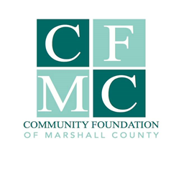
2019 CFMC IMPACT GRANT FINAL REPORT

***All final reports must be submitted by 12.31.19 in order to be eligible for 2020 CFMC Grants***

I. Organization & Project Information

Organization Submitting Report

Project Name (3-5 words)
$ $
Total Project Cost CFMC Grant Award

Organization Contact Person (name, phone and email address)

Is your project complete? ___Yes (complete final report) ___No (see below)

If no, explain why and when you expect it to be completed below: (25 words) – final report cannot be completed until all funds have been expended or returned to CFMC. Please contact Julie Hitchins, Executive Director, CFMC to discuss further.

Number of people directly served by this project annually Duplicated/Unduplicated Count

Project time line (start and finish dates)

II. FINAL REPORT NARRATIVE

Restate from the original application, a summary of your project description. (50 words)

II. FINAL REPORT NARRATIVE (continued)

What was the critical need your project addressed? Please describe the largest impact of your project in terms of meeting that critical need. (100 words)

Were there any barriers you encountered or was there a positive impact that was unexpected? (50 words)

Briefly restate the anticipated measured outcomes and compare to actual measured outcomes from your project. (100 words)

If applicable, restate from the original application, the sustainability plan presented at the time of application and if this is still a valid plan or your current plan to sustain the project (50 words)

III. FINAL REPORT EXPENDITURES

Please complete the excel spreadsheet Final Grant Financial Report. Instructions on how to complete this report are within the excel file. Note: for expenses funded by CFMC grant funds please include copies of invoices for items or services purchased. Below please state any comments or additional information regarding your financial report below. (50 words)

IV. FINAL REPORT CHECKLIST & Submission

_________ Final Report Narrative

_________ Final Report Grant Expenditures

_________ Photos from your project that CFMC may use for publicity purposes

All applications & related documents must be submitted electronically to the CFMC via email to director@cfmarshallco.org. You will receive a confirmation email acknowledging receipt of the application. If you do not receive an email acknowledging receipt, you must follow up by calling the office at 641.758.3028.

