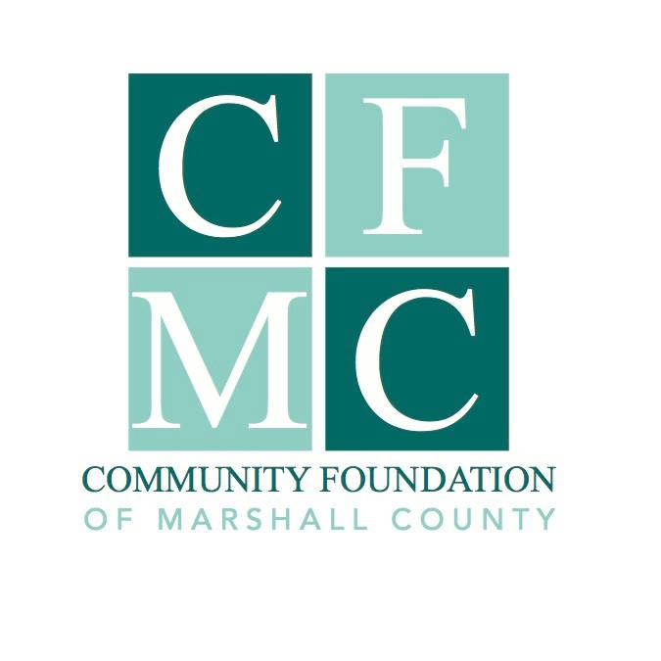
2020 Community Foundation of Marshall County Grant Guidelines

The Community Foundation of Marshall County (CFMC) awards grants to nonprofit organizations serving Marshall County, and partners with individuals, families, and organizations to create permanent endowments. The CFMC is an affiliate of the Community Foundation of Greater Des Moines and is therefore eligible to offer the Endow Iowa Tax Credit.
Grant Guidelines

The 2020 Community Foundation of Marshall County (CFMC) Grant will provide up to $7,500 in funding to an organization’s project that will have a lasting impact on how the citizens of Marshall County live, work, learn or play. Funding decisions are made through a competitive application process.

2020 Funding Available

There will be approximately $65,000 available for the 2020 Impact Grant cycle.

Eligibility

Funding is available to non-profit, I.R.S. 501(c)(3) tax-exempt organizations, 170(b) units of government organizations or charitable organizations without the above designations through a qualified fiscal sponsor. It is preferred that only one proposal is submitted per organization.

Grant Conditions

- The grant application should be for a specific project
- The maximum grant award per project is $7,500
- If an applicant received a grant award in 2019, all reporting must be up to date
- Projects must be completed by December 31, 2020.

Grant Cycle Timeline

November 25, 2019 : Grant application materials available
*December 6, 2019 : Informational session at noon at Marshalltown Public Library Community Room
January 10, 2020 : Application is due
March 24, 2020 : grant awards ceremony at 5:00 p.m.

*If you are unable to attend the informational session it is recommended that you contact Julie Hitchins, Executive Director, by phone at 758-3028 or email at director@cfmarshallco.org prior to submitting application materials.

Application

The application materials include two files: this document (word) and an Excel spreadsheet for project financial reporting.

Evaluation

Grant application materials will be reviewed and evaluated for:
- The project’s positive impact on how the citizens of Marshall County live, learn, work and play.
- The population that your project serves
- The financial feasibility and support from other financial and human resources.
- How the project fits with other community plans (i.e. city plans, community visioning plans).
- If the project has a well-planned approach, committed leadership and the involvement of individuals with the skills necessary to carry out the project.
- The use of collaborative strategies that support efficiencies, increase effectiveness and build leadership for achieving broader impact without duplication.

Submission Procedures

Application materials must be submitted electronically to the CFMC via email at director@cfmarshallco.org or before Friday, January 10, 2020 at 4:00 p.m.

You will receive a confirmation email acknowledging receipt of your application materials. If you do not receive an email acknowledging receipt, you must follow up by calling the office at 641.758.3028 by January 22nd at 4:00 p.m.

Nondiscrimination Policy

The Community Foundation of Marshall County does not discriminate on the basis of race, ethnicity, color, religion, gender, gender identity or expression, sexual orientation, disabilities, age, status as a veteran, national origin or any other projected class. Applications for Community Foundation of Marshall County Grants must hold similar standards in provision of services.

Program Terms and Limitations

CFMC will determine when the grant award is disbursed based on the project presented. Grant funding must be for expenses incurred after the grant award date.

Grant Awards

The grant recipient may be asked to provide CFMC with photographs and narrative in order to publicize your project via social media, web site, press releases, etc., participate in interviews program at our annual awards ceremony.

The grant recipient will be required to submit a final report on or before December 31, 2020.

For more information, please contact Julie Hitchins, Executive Director, by phone at
758-3028 or email at director@cfmarshallco.org

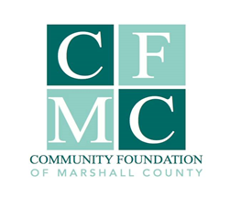
2020 CFMC Grant Application

I. Organization & Project Information

Organization Requesting Funding Organization Federal Tax Identification Number

Organization Address

Organization Contact Person (name, phone and email address)

Is your organization an IRS 501(c)(3) not-for-profit? ___Yes ___No
If no, is your organization a 170b unit of the government? ___Yes ___No

If no, you must have a fiscal sponsor and complete the Fiscal Sponsorship Agreement and the following:

Fiscal Sponsor Name Fiscal Sponsor Federal Tax Identification Number

Project Name (3-5 words)

Summary of your project request and how it will have a lasting impact on how the citizens of Marshalltown County live, learn, work and play. (50 words)

$ $ %
Total Project Cost Amount Requested from CFMC % of total cost requested from CFMC

Estimated number of people directly served by this project annually Duplicated/Unduplicated Count

Project time line (start and finish dates)

2020 CFMC Grant Application

II. GRANT APPLICATION NARRATIVE

- Need: Describe the need within Marshall County that your project will be addressing; use surveys, data, anecdotes, etc. (250 Words)

- Project Description: Provide a complete project description that includes: (500 Words)
What is the project?
Who does the project benefit?
Where does the project benefit? (what communities? County-wide?)
When will the project take place?
How will the funds be used?

- Description of Organization conducting the project: Describe your organization’s charitable purpose, program activities and population served. (100 Words)

- Sustainability: If the project is ongoing how will it be maintained in future years? (100 Words)

- Collaboration: Are you collaborating with other community partners on this project? Are there other organizations providing the same service and how are you coordinating your efforts? (100Words)

- Project Evaluation/Assessment: What is the expected outcome(s) of the project and how will you measure expected results? (250 Words)

III. PROJECT BUDGET

- Provide a detailed project budget (worksheet & instructions provided). The Project Budget worksheet should include project income and estimated costs to implement the project. You may also attach cost estimates from suppliers for items that you wish to have funded by this grant. Please state any comments or additional information for review and consideration of your project budget below. (100 words)

- If your project receives only partial funding from the CFMC, how will this affect your ability to complete the project (50 words)

2020 CFMC Grant Application

IV. Project Certification

Applicant Organization Board Approval: We approve submission of this grant request and certify that monies received from CFMC will be used solely for the project stated in this application.

We will recognize the CFMC as a funding agency for this project both in the short and long term.

We understand that the decision of the CFMC is solely the decision of the Foundation Board and that their decision is final.

Organization Highest Authorized Individual:

____________________________ __________________________________ _________________
Signature Printed Name Date

V. APPLICATION CHECKLIST

_________ Organization & Project Information (Page 3)

_________ Grant Application Narrative (Page 4)

_________ Project budget (excel sheet), related attachments and narrative (page 4)

_________ project certification with signatures (Page 5)

_________ List of board/council members of applicant& sponsor (if applicable) organization

Please limit additional attachments to 3 pages or less; no letters of support.

VI. grant application submission

All applications & related documents must be submitted electronically to the CFMC via email to director@cfmarshallco.org. or before Friday, January 10, 2020 at 4:00 p.m.

You will receive a confirmation email acknowledging receipt of the application. If you do not receive an email acknowledging receipt, you must follow up by calling the office at 641.758.3028 by January 22nd at 4:00 p.m.

Please contact Julie Hitchins, CFMC Executive Director, at director@cfmarshallco.org or 641-758-3028 with questions.

2020 CFMC Grant Fiscal Sponsorship Agreement

This must be completed if the organization requesting funding is NOT classified by the IRS as a 501(c)(3) not-for-profit or a 170b unit of the government

Fiscal Sponsor Fiscal Sponsor Federal Tax Identification Number

Fiscal Sponsor Address

Fiscal Sponsor Contact Person (name, phone and email address)

Sponsored Organization Conducting the Project

Name of Project (3-5 words)

Fiscal Sponsor, hereafter referred to as The Sponsor, has agreement to serve as fiscal/program sponsor for the Sponsored Organization Conducting the Project (named above), hereafter referred to as the Sponsored Organization as outlined in the attached application and supporting materials. The Board of Directors of The Sponsor has passed a resolution adopting the Sponsored Organization’s project as a program or project consistent with the Sponsor’s purpose and mission. The Sponsored Organization’s financial activities will be accounted for as a program of The Sponsor for IRS auditing and financial purposes.

Since the Sponsored Organization is not recognized by the IRS as a charitable tax-exempt entity, The Sponsor must exercise full control over the Sponsored Organization’s financial administration, management and distribution of funds resulting from this grant application. The Sponsor has delegated ______________ (name person(s)) as responsible for fulfilling of these accounting and reporting functions subject to the ultimate authority of the Board of Directors of The Sponsor. The Sponsor is responsible for ensuring completion of timely reports and submission of neccessary financial statements to the Community Foundation of Marshall County. Failure to insure timely reporting on behalf of the Sponsored Organization/Sponsor will also result in loss of good standing.

This agreement will be in effect from the date of the grant award to support the above-named project until the grant funds are expended and the final report has been submitted and accepted.

We agree to the terms stated above in this agreement:

Fiscal Sponsor Representative Signature Printed Name Date

Sponsored Organization Representative Signature Printed Name Date

*Attach to this agreement the Fiscal Sponsor’s 501(c)(3) Tax Exempt Determination Letter or comparable proof of charitable exemption (i.e. a letter from a City, confirming their status as a government entity. Contact the Community Foundation of Marshall County with questions.

