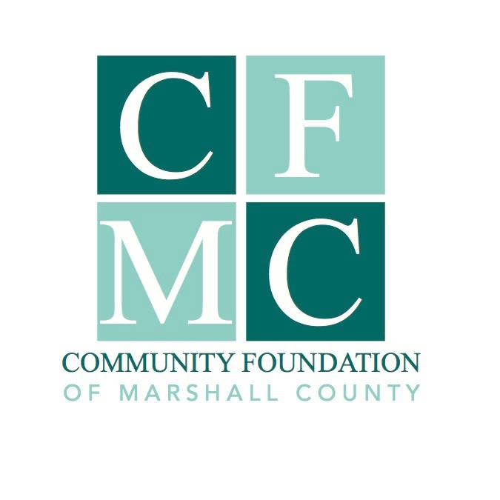
Community Foundation of Marshall County Rebuild Marshalltown Fund

Purpose
The Community Foundation of Marshall County Rebuild Marshalltown Fund will support opportunities for tax-exempt, non-profit entities classified by the IRS as 501(c) (3) organizations, public schools, or government entities to engage in activities around the rebuilding and sustainability of the built environment of Marshalltown after the July 2018 tornado. Proposals which include projects based in community plans (i.e. city plans, community visioning plans), collaboration with other local organizations and sustainable rebuilding efforts, will take priority.

2020 Eligibility and Guidelines
This grant opportunity is open, by invitation only, through the Letter of Intent process outlined above to qualified, eligible, not-for-profit organizations holding a 501(c)3 or equivalent IRS status. Minimum request amount is $20,000. Funds must be used for mid-to-long term recovery and rebuilding efforts in the tornado affected area. Applicants are required to demonstrate investment in projects by providing cash match that is a minimum of 50% of the total grant amount requested from CFMC. All invited grant application submissions must include the completed application, along with a detailed project budget. Grant applicants are eligible to submit one project for funding, per cycle.

2020 Letter of Intent Deadlines
The deadlines for Letter of Intent submission is as follows:

February 3, 2020
July 1, 2020
October 1, 2020

Program Terms and Limitations
Funds will be awarded to grant recipients on a reimbursement basis after expenses have been incurred for approved project activities. Project activities prior to award are not eligible for reimbursement. All project activities, incurred expenses and draw down of funds must occur within two years of grant award. Grant recipients will be required to submit project-end reports on how the grant funding was utilized to achieve their goals in rebuilding efforts. No grants can be made to individuals or businesses; aid to individuals and businesses may be done through nonprofit organizations with established processes for determining need.

Review Process
Letters of Intent should be no more than two pages in length, using 12 point font, single spaced. They should include a narrative of the project and demonstrate the following:

*Proposed project is within the affected tornado area in Marshalltown
*Describe the project impact on the broader community
*Total project cost, amount requested from Rebuild Marshalltown Fund and match amount
*Applicant has demonstrated matching funds (committed/secured)
* Proposed project engages in activities around the rebuilding and sustainability of Marshalltown and addresses the built environment
* Proposals which include projects based in community plans (i.e. city plans, community visioning plans), collaboration with other local organizations and sustainable rebuilding efforts, will take priority

Letters of Intent: Submitted Letters of Intent are reviewed by CMFC Executive Director for completion, eligibility, and the ability to meet the guidelines. The Rebuild Marshalltown Fund Review Committee will review eligible Letters of Intent to determine whether the applicant will be invited to submit a full application.

Full Applications: Applications will be reviewed by CFMC Executive Director for completion, eligibility and the ability to meet the guidelines. The Rebuild Marshalltown Fund Review Committee will review eligible applications and make funding recommendations to the Community Foundation of Marshall County Board of Directors.

The fund will award grants based on available resources and merits of the project. There is no one set of criteria that if met, will guarantee funding. These guidelines are subject to change as community needs evolve in the rebuilding process.

For more information, please contact Julie Hitchins, Executive Director, by phone at
758-3028 or email at director@cfmarshallco.org

