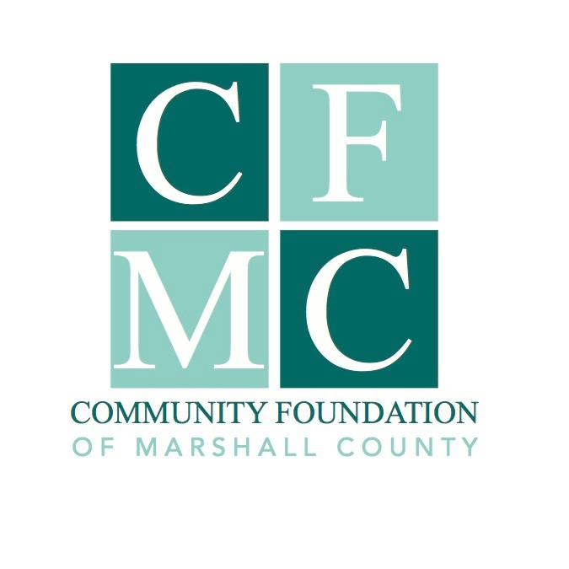
Marshall County Disaster Recovery Fund

2021 Derecho Recovery Grant Guidelines

Purpose

The Community Foundation of Marshall County (CFMC) established the Marshall County Disaster Recovery Fund (MCDRF) to support both relief (basic needs after a disaster) and recovery (long term needs) in the event a disaster would occur in Marshall County.
The intention of the MCDRF’s grant support is to supplement, not replace, other resources including individual government support and other funding sources.

Currently the MCDRF is supporting both the pandemic and derecho disasters which occurred in 2020. These grant guidelines are specifically for derecho recovery.

Organization Eligibility

Funding is available to non-profit, I.R.S. 501(c)(3) tax-exempt organizations, 170(b) units of government organizations or charitable organizations. Organizations without the above designations may utilize a qualified fiscal sponsor and should contact CFMC to obtain a Fiscal Sponsorship Agreement to complete.

Grant Guidelines

- This grant opportunity is open, by invitation only, through a Letter of Intent process outlined below. Successful applicants will be invited to complete a full application and project budget.
- There is approximately $90,000 available for this grant funding cycle.
- There is no minimum or maximum grant amount.
- Funds must be used for a specific program or project related to derecho recovery and rebuilding efforts within Marshall County.
- An organization may only submit one program or project for this grant cycle.
- The grant request may be for expenses already incurred or expenses that will be incurred after the grant award.
- There is no matching funding requirement.
- Projects must be completed within two years of the grant award.
- No grants can be made to individuals or businesses; aid to individuals and businesses may be done through nonprofit organizations with established processes for determining need.

2021 Letter of Intent Process (Due 06/25/2021 by 4pm)

To be eligible for consideration letters of intent must include the following information:
- Organization name, organization address and tax identification number.
- Contact information (email and phone number) for the individual responsible for answering questions regarding the program or project.
- A narrative describing the project or program and how it will positively impact Marshall County.
- Total project cost, amount requested from the MCDRF, and other secured and unsecured funding sources.
- If warranted how the project fulfills one or more of the priority areas listed below.

Projects given funding priority:
- Proposed project or program has additional funding sources.
- Sustainable projects which align with community-based plans (i.e. city plans, county plans, visioning plans, etc.)
- Programs which align closely with statistical data regarding community need.
- Projects or programs that have a well-planned approach, committed leadership and the involvement of individuals with the skills necessary to carry out the project.

Your Letter of Intent should be no more than two pages in length, using 12 point font, single spaced. There should be no additional attachments.

Letters of intent should be submitted electronically to director@cfmarshallco.org by 4:00 p.m. on June 25, 2021. You will receive a confirmation email acknowledging receipt of your letter of intent. If you do not receive an email acknowledging receipt, you must follow up by calling the office at 641.758.3028 by June 28th at noon.
Submitted Letters of Intent are reviewed by CMFC Executive Director for completion, eligibility, and the ability to meet the guidelines.

The MCDRF Committee will review eligible Letters of Intent to determine whether the applicant will be invited to submit a full application.

2021 Application Process

The MCDRF Committee will review eligible applications and may request an interview with the grantee. The MCDRF Committee will make funding recommendations to the CFMC Board of Directors.

The fund will award grants based on available resources and merits of the project. There is no one set of criteria that if met, will guarantee funding. These guidelines are subject to change as community needs evolve in the recovery process.

Nondiscrimination Policy

CFMC does not discriminate on the basis of race, ethnicity, color, religion, gender, gender identity or expression, sexual orientation, disabilities, age, status as a veteran, national origin or any other protected class. Organizations applying for CFMC Grants must hold similar standards in provision of services.

Grant Awards

The grant recipient may be asked to provide CFMC with photographs and narrative in order to publicize your project via social media, web site, press releases, etc., and participate in other media events.

For more information, please contact Julie Hitchins, Executive Director, by phone at
758-3028 or email at director@cfmarshallco.org

