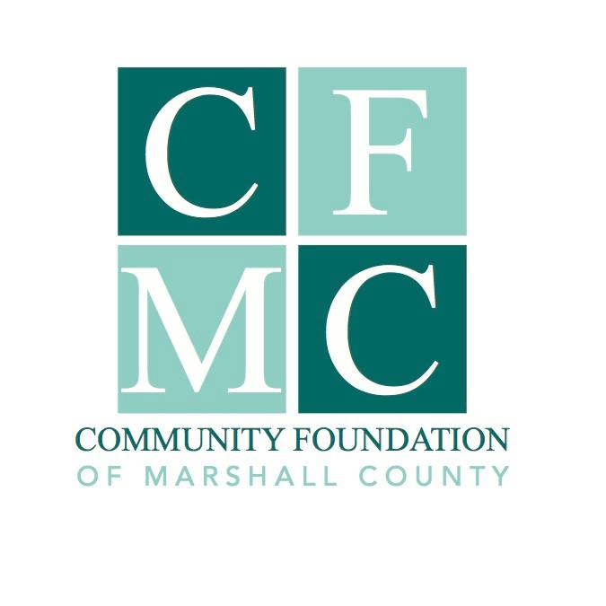
2022 Community Foundation of Marshall County Grant Guidelines

Advancing Marshall County as a place to thrive!

The Community Foundation of Marshall County (CFMC) awards grants to nonprofit organizations serving Marshall County, and partners with individuals, families, and organizations to create permanent endowments. The CFMC is an affiliate of the Community Foundation of Greater Des Moines and is therefore eligible to offer the Endow Iowa Tax Credit.
Grant Award Priority Projects:

CFMC Board recognized the great outcomes and positive impact from the 2021 grant focus which gave priority to projects that enabled Marshall County to come back stronger and better than before. To continue this positive momentum this year, projects that embody CFMC’s new vision statement; “Advancing Marshall County as a place to thrive!” will be given priority.

Grant Guidelines

The 2022 Community Foundation of Marshall County (CFMC) Grant is open through the letter of intent process. All interested applicants start by submitting a letter of intent to the CFMC Board of Directors for review. Grant application materials will be offered by invitation only to selected applicants. Final submissions must include the completed application, along with a detailed project budget. Funding decisions are made through a competitive application process.

2022 Funding Available

$88,500 is available for the 2022 grant cycle.

Eligibility

Funding is available to non-profit, I.R.S. 501(c)(3) tax-exempt organizations, 170(b) units of government organizations or charitable organizations without the above designations through a qualified fiscal sponsor. Organizations must be in good standing with CFMC which includes completion of prior grant projects and submission of the related final report.

Grant Conditions

- The letter of intent must be for a specific project
- One letter of intent may be submitted per organization
- The minimum grant award per project is $1,000 with the maximum not to exceed funding available
- Projects must be completed by December 31, 2022

Grant Cycle Timeline

Friday, November 5, 2021 at 12:15 p.m.: Informational Meeting via Zoom
Monday, November 29, 2021: Letter of Intent due by noon
Wednesday, December 22, 2021: Applicants notified if they are invited to complete application
Monday, January 28, 2022: Grant applicants due by noon
March, 22, 2022: Grant Award Ceremony

*If you are unable to attend the informational session it is recommended that you contact Julie Hitchins, Executive Director, by phone at 758-3028 or email at director@cfmarshallco.org prior to submitting your letter of intent.

Letter of Intent

Letter of Intent should include grantee contact information: individual responsible for answering questions, mailing address, email address and phone number and a narrative of the project including:

*Project description
*Who will benefit from the project
*How the proposed project will “Advance Marshall County as a place to thrive”
*Total project cost, amount requested from this grant and other secured funding
*If warranted, how the project fulfills one or more of the priorities listed below

Letter of Intent should be no more than two pages in length, using 12 point font, single spaced. There should be no additional attachments.

Projects given priority

- Projects that will “Advance Marshall County as a place to thrive”
- Projects that positively impact the future of Marshall County
- Transformational and/or forward looking projects
- Projects that require just one time funding

Evaluation

Letters of Intent will be reviewed and evaluated for:

- Positive impact on advancing Marshall County as a place to thrive
- The population that your project serves
- The financial feasibility and support from other financial and human resources
- How the project fits with other community plans (i.e. city plans, community visioning plans)
- A well-planned approach, committed leadership and the involvement of individuals with the skills necessary to carry out the project
- Use of collaborative strategies to support efficiencies, increase effectiveness and build leadership for achieving broader impact without duplication

Submission Procedures

Letters of Intent must be submitted electronically to the CFMC via email at director@cfmarshallco.org or before Monday, November 29, 2021 at NOON.

You will receive a confirmation email acknowledging receipt of your letter of intent. If you do not receive an email acknowledging receipt, you must follow up by calling the office at 641.758.3028 by November 30 at noon.

Nondiscrimination Policy

The Community Foundation of Marshall County does not discriminate on the basis of race, ethnicity, color, religion, gender, gender identity or expression, sexual orientation, disabilities, age, status as a veteran, national origin or any other protected class. Organizations applying for Community Foundation of Marshall County Grants must hold similar standards in provision of services.

Program Terms and Limitations

CFMC will determine when the grant award is disbursed based on the project presented. Grant funding must be for expenses incurred after the grant award date.

Grant Awards

The grant recipient may be asked to provide CFMC with photographs and narrative to publicize the project via social media, web site, press releases, etc.

The grant recipient will be required to submit a final report on or before December 31, 2022.

For more information, please contact Julie Hitchins, Executive Director, by phone at 758-3028 or email at director@cfmarshallco.org

CFMC Board Approved 10.26.2021

