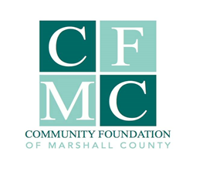
2021 GRANT FINAL REPORT

***All final reports are due on or before 12.31.21 in order to be eligible for 2022 grants***

I. Organization & Project Information

Organization Submitting Report

Project Name (3-5 words)
$ $
Total Project Cost CFMC Grant Award

Organization Contact Person (name, phone and email address)

Is your project complete? ___Yes (complete final report & Expenditures worksheet)
___No (contact CFMC @ 758-3028)

Unduplciated Number of Marshall County residents directly served by this project annually:

Application:____________________ Actual Number Served:_____________________________

Actual project time line (start and finish dates)

II. FINAL REPORT NARRATIVE

Restate from the original application the summary of your project request. (50 words)

II. FINAL REPORT NARRATIVE (continued)

Please describe the positive impact of your project had in making Marshall County a better place to live, learn, work and play. (100 words)

Were there any barriers you encountered and how were they addressed? (50 words)

Briefly restate the anticipated measured outcomes and compare to actual measured outcomes from your project. (100 words)

If applicable, restate from the original application, the sustainability plan presented at the time of application and if this is still a valid plan or what is your current plan to sustain the project (100 words)

III. FINAL project Expenditures worksheet

On the Final Project Expenditures Worksheet, you will report the project budget from your original application as well as actual grant expenditures. Please refer to the “instructions” sheet on the Excel file for information how to complete the Final Project Expenditures Worksheet. Note for expenditures for material or services require provide proof of purchase which may include invoice, purchases detailed via accounting system, payment documents, etc. You may state any additional information regarding expenditures below. (100 words)

IV. FINAL REPORT CHECKLIST & Submission

_________ Final Report Narrative

_________ Final Report Project Grant Expenditures Worksheet

_________ Photos from your project that CFMC may use for publicity purposes

The Final Report & related documents must be submitted electronically to the CFMC via email to director@cfmarshallco.org. You will receive a confirmation email acknowledging receipt of the application. If you do not receive an email acknowledging receipt, you must follow up by calling the office at 641.758.3028.

